**For having a report like this:**

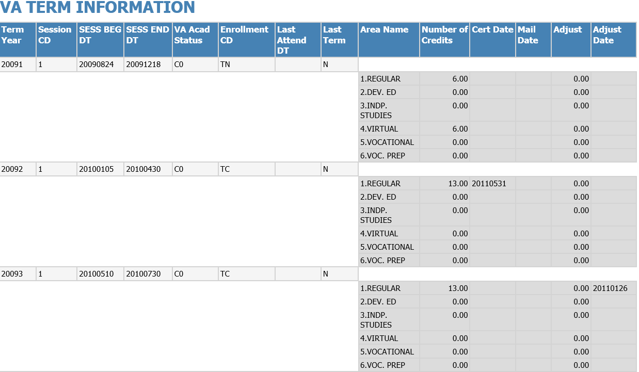

**Steps:**

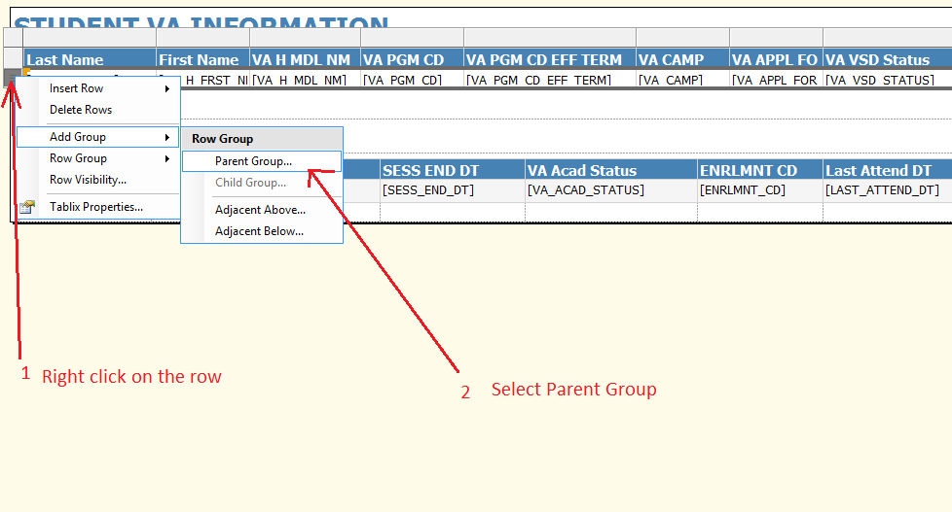

Select the column you want to group for and click OK:

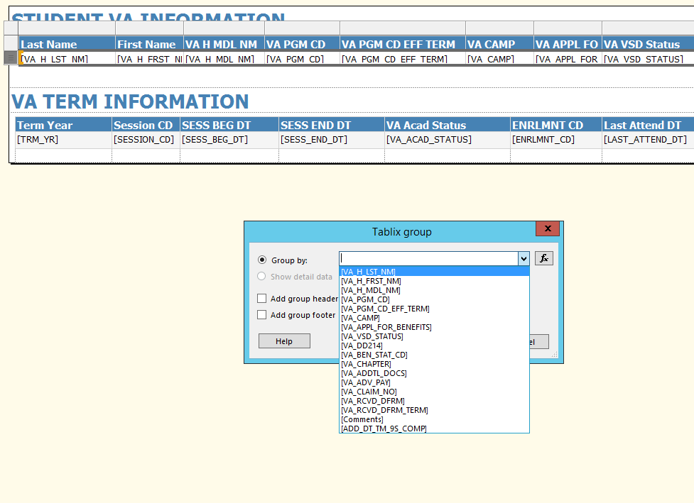

In this case we are grouping by the first column VA_H_LST_N (Last Name). Notice there are now two first columns under the same name:

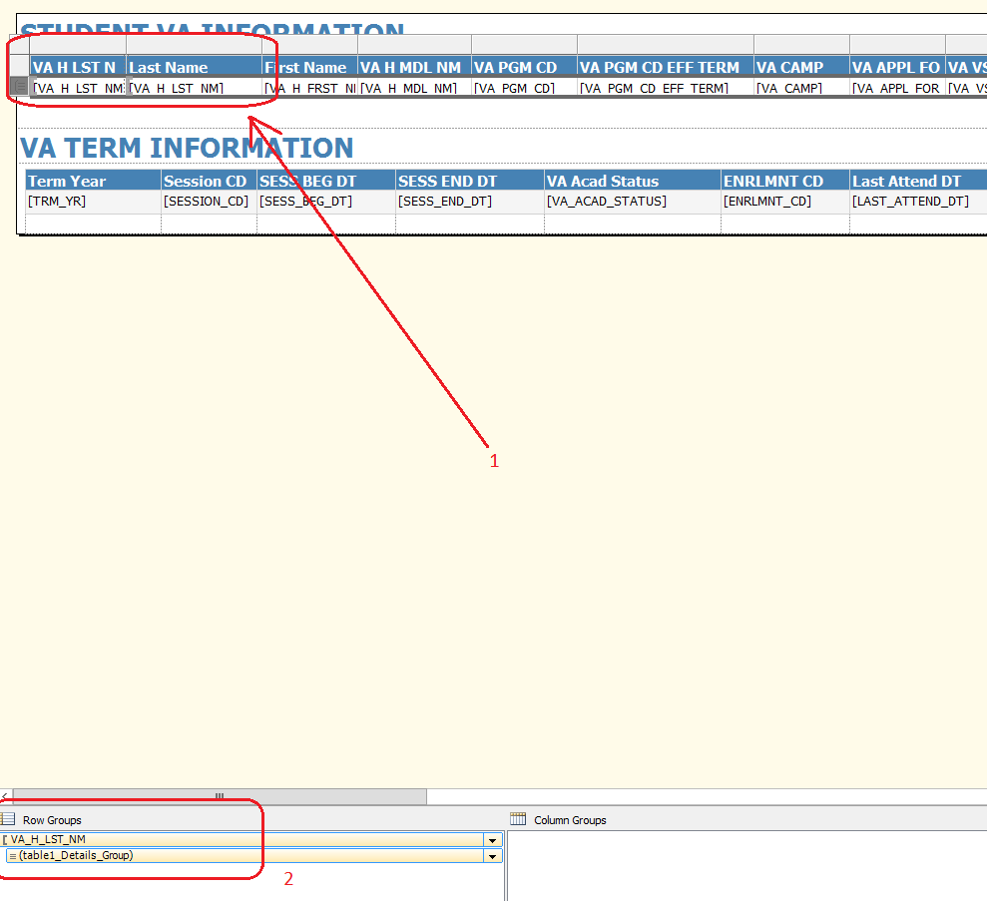

Let’s delete the first one:

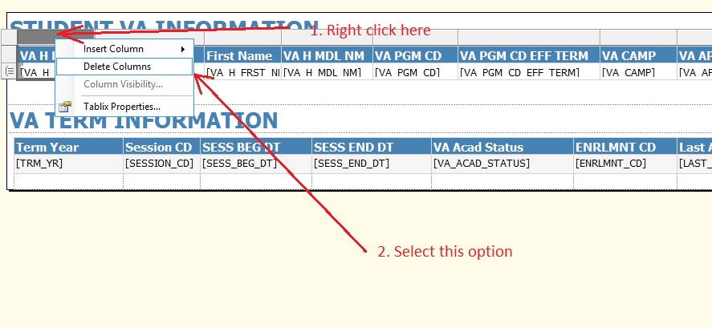

Select “Delete columns only”, leave the created group as is and click OK:

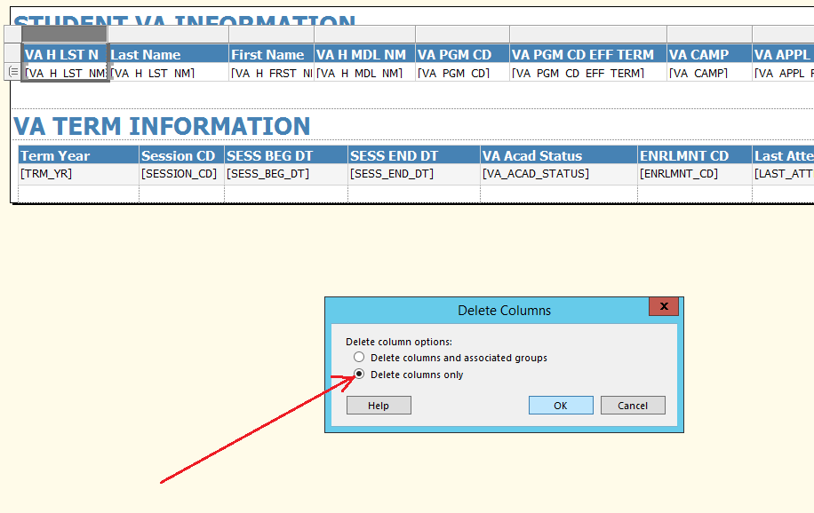

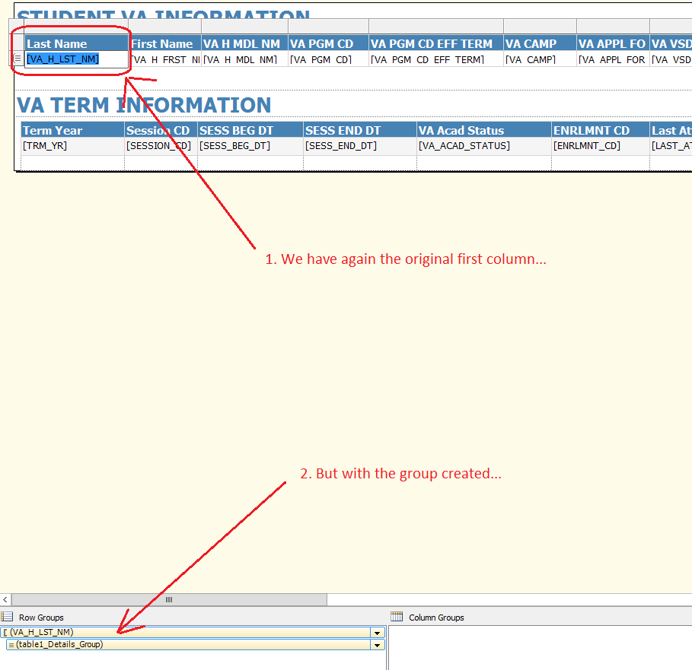

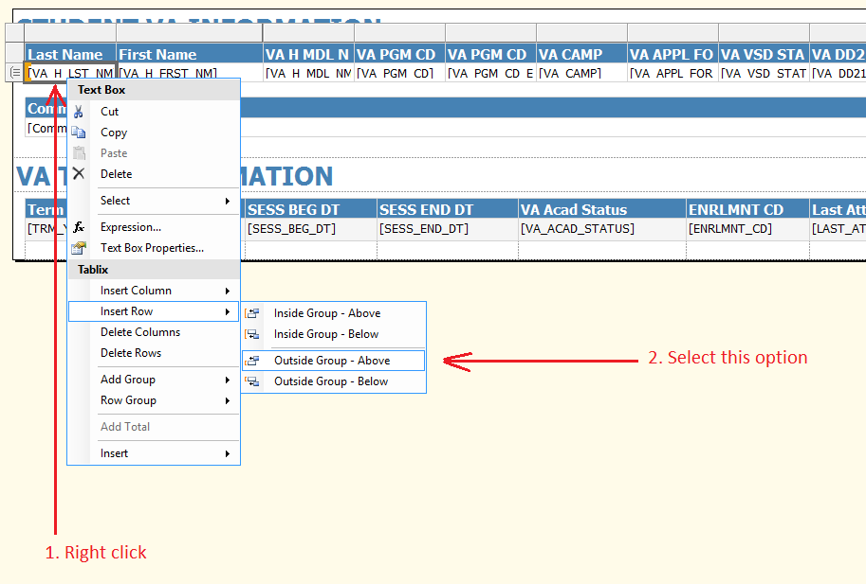

A new row was inserted above:

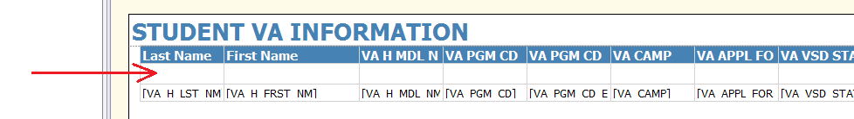

Reorganize the columns values accordingly:

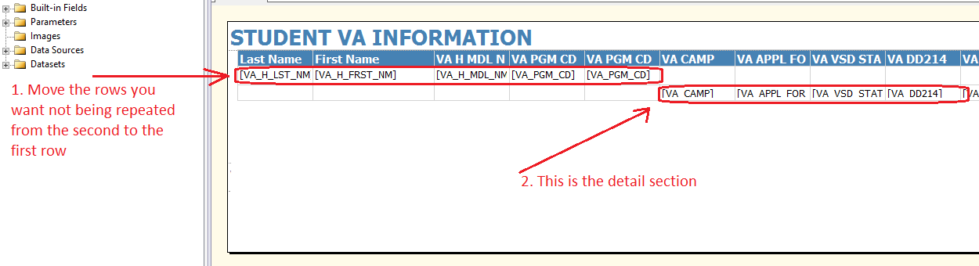

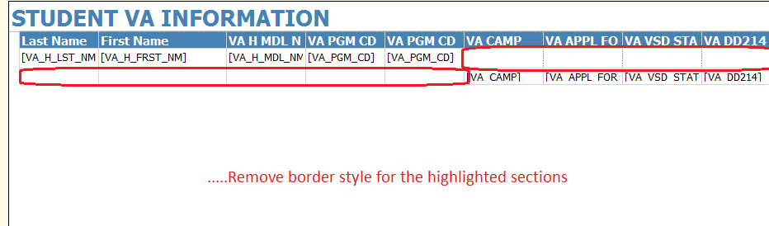

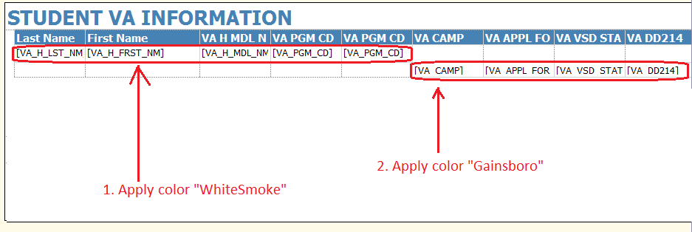

And it will look like this:

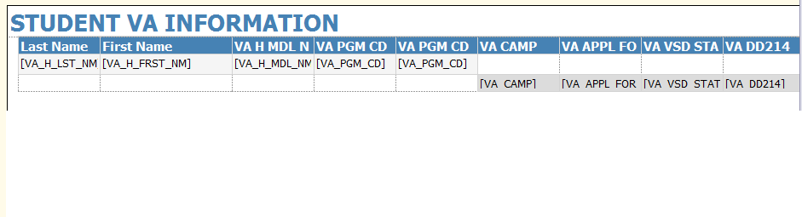

**Setting the Group Visibility while scrolling & moving between pages:**

In order to keep group headers visible while scrolling up/down and moving between report pages, click on the Row/Column groups Advanced Mode:

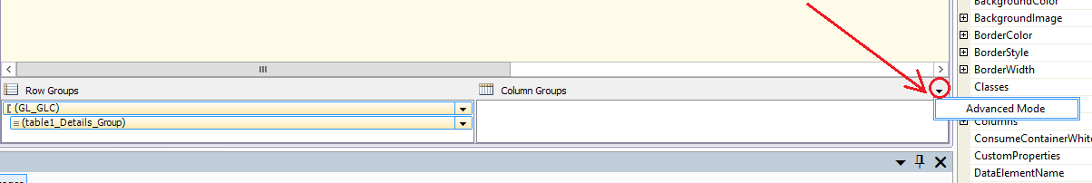

Set the following properties as specified in the next screens:

